- February 2019 variant1 task2:
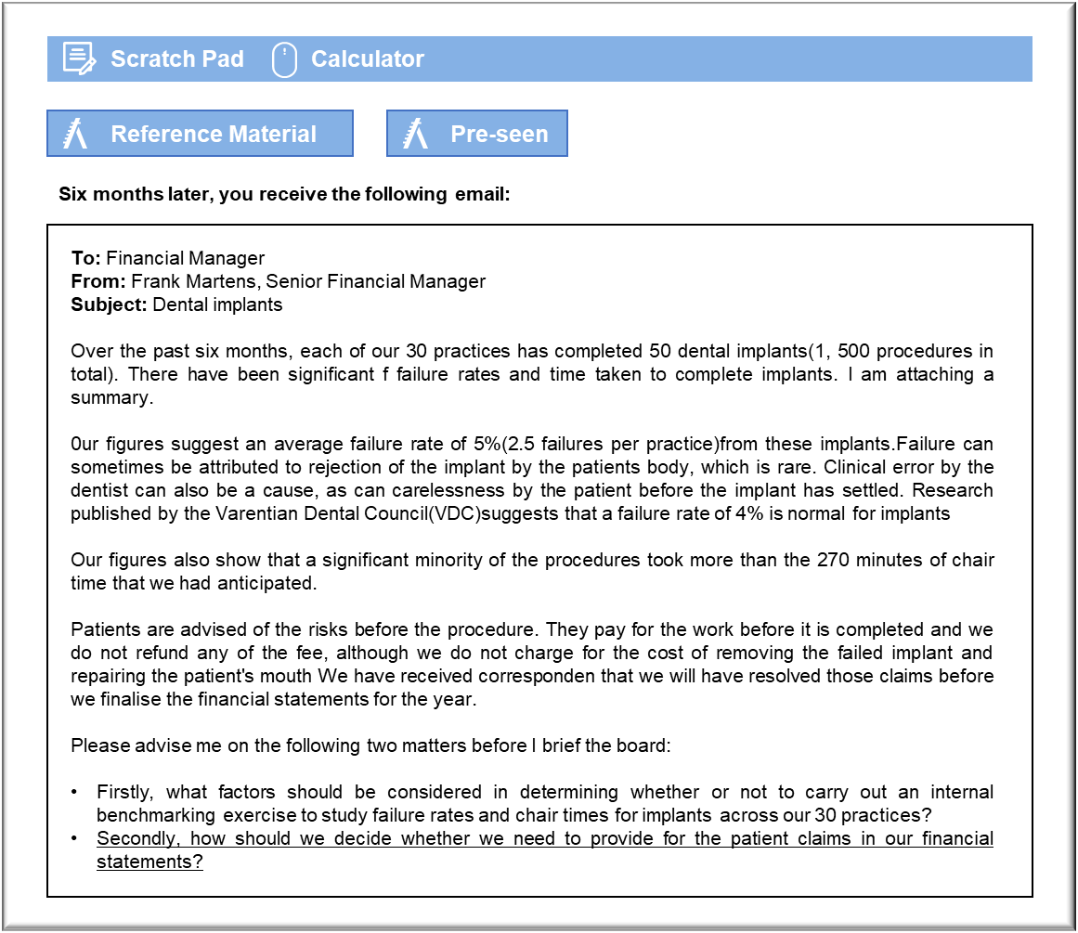

Benchmarking

The purpose of the internal benchmarking exercise has to be decided. For example, will it focus on metrics, processes or diagnostics? There may be little meaningful information to be had from comparing metrics if, say, failure rates are driven by relatively uncontrollable factors such as patient suitability for the procedure. It may be that the practices that have reported seven or eight failures have simply been unlucky and that they have relatively little to learn from their counterparts with none or one.

Crowncare has 30 dental teams who have been trained to carry out this procedure. That suggests that there is relatively little to benchmark in terms of comparing processes because there will be external benchmarks and protocols for fixing implants and all dentists should be adhering to that. Arguably, benchmarking should be measured against external procedures and standards for dental care and hygiene. If any of Crowncare’s dentists believe that they have identified better approaches to this procedure then it might be more efficient to create a forum in which they can exchange ideas with colleagues, rather than benchmarking across the company.

The board should consider whether the benchmarking exercise might lead to dysfunctional behaviour or motivational problems. The fact that some procedures took longer than others could have little or nothing to do with the skill and care taken by the dental teams. Some patients will encounter problems with this procedure and will require more time. Benchmarking chair times could imply that Crowncare is keen for all implants to be completed within 270 minutes and that any additional time was a sign of poor clinical techniques or inefficiency.

It is worth considering whether it is too soon to get the greatest benefit from benchmarking. The dentists have averaged two procedures each over the past six months and so their individual averages could be affected quite significantly by one or two failed implants or one or two difficult patients. The dentists whose performance appears stronger could just as easily have benefitted from good luck in terms of the patients whom they have treated It may be worth considering delaying for, say, a further six months in the hope that the statistics might stabilise.

Claims

The first issue to be decided is whether the claims could result in a material loss to Crowncare. It would not be appropriate to make an entry unless there is a potential loss. The company will undoubtedly be insured against such claims and so the first thing that should be considered is whether the cost of any successful claim would be covered by the policy. We should consult with our insurer in this matter, with a view to establishing whether they will accept liability. If they will then there will be no net loss. If the insurer cannot or will not give a clear response, or if the policy does not cover these claims then the next step is to establish whether disclosure is required under IAS 37 Provisions, Contingent Liabilities and Contingent Assets.

The most immediate issue is the amount claimed by the patients. If the total value sought is immaterial then there is little need to consider the accounting issues any further. If the claim is open-ended then it may be possible to obtain some guidance from Crowncare’s lawyers, who will be aware of the precedents set in other cases.

If a reliable estimate can be made of the likely cost of settling these claims then Crowncare will have to create a provision. The other criteria for the recognition of a provision are that there is a present obligation from a past event and that those will require an outflow of resources. Both of these are met. The cost will appear as both an expense in the current year’s statement of profit and loss and as a liability in the statement of financial position.

If a reliable estimate cannot be made then the claim should be disclosed in the notes to the accounts as a contingent liability. The disclosures should include an estimate of the financial effect of the settlement, an indication of the uncertainties and the possibility of any reimbursement. The only real accounting question is whether the likelihood of a payment is remote. If so, the disclosure would be unhelpful and so would not be required.

